Smith Regatta meeting 1/27/2020
In Attendance: Wright Finney, Gena Thompson, Linda Downey, Bill Olsen, Kristin Korinko, Deb Berlinger, Joe Sisson, Bob Graves, Sandy Layne.
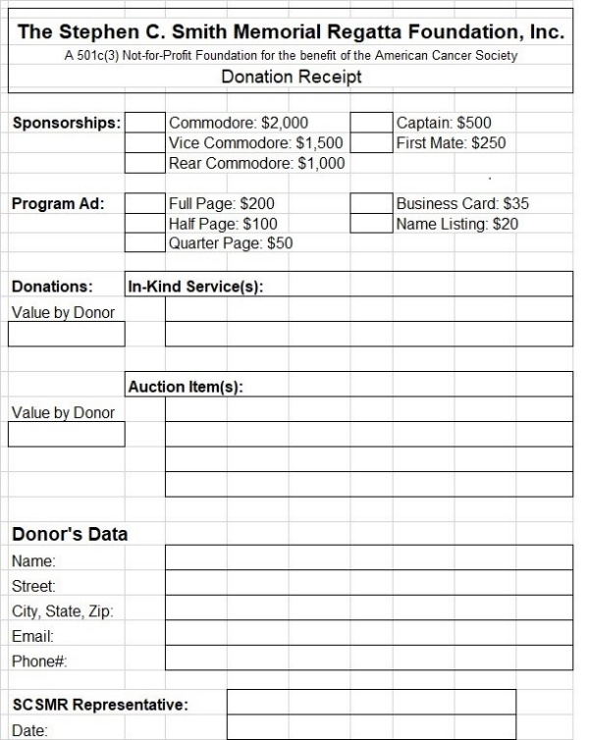
The emphasis for the month of February, which is why there is no meeting, is to get DONATIONS! Get with the folks you have before. Everyone at the meeting to a stack of triplicate donation forms so that they can fill it out on the spot and give a copy to the vendor. If you would like some, please let me know and I’ll get them to you. This is what they look like, only bigger.
We discussed the save the date card and any changes to it. For publicity we have Dave Denmark volunteering for public appearances, and hopefully Lisa, Kristin, Rose, me, and Stan. A large group to pull from.
Gena, who is handling registration, had a bunch of questions but seemed to very on top of what to do. We will talk more as time winds down some of the step by step stuff in getting it together. Gena already has her team of folks. Emphasis was put on requiring folks to be at the registration desk to get a beer bracelet.
Bob will meet with Lisa and Rose about the auction soon since neither of them could make the meeting. Linda is going to check into getting a small storage unit for us to put things prior to the auction.
Schedule of events time changes are as follows: Breakfast is now from 8:30 to 10 (used to be at 8) and lunch will be from 11-3 on Saturday and 11-2 on Sunday (used to be 10:30-3 on both days)
One thing I ask is to communicate! If you need something or need help, call me at 508-1587. I may not be able to help, but together we can get it done. Also, please try and respond to emails on a timely manner.
Next meetings are schedule for March 2nd and April 6th, in the 4th quarter at 6:30.

Thank you all for volunteering again!

