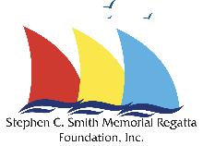
Smith Planning Committee Agenda
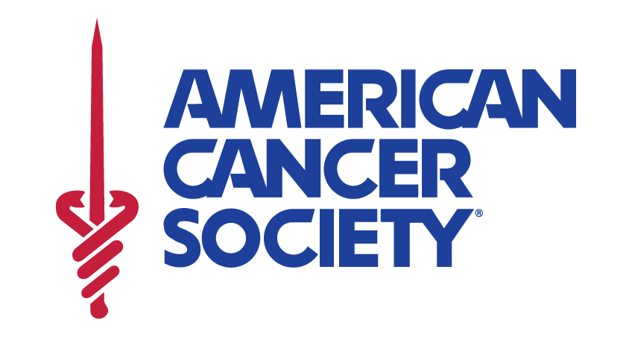
February 12, 2024
Casa Grande Margaritas & Cocina – Midtown
Backroom, 1800 Thomasville Road

- Publicity – the Save the date announcement has gone out to ABYC and SPSC members and has been posted on Facebook.
- Billboards - Per the meeting 1/8/24 Marianne reported we will have 3 digital billboards, possibility of an additional one. Need to use a different picture, something more simple, easier to see/understand as drive by.
- TV – WCTV will, WTXL no update, FSU will offer radio, no TV.
  - Who will do TV and radio spots?
  - Script?
- Signs – Details to Marianne by what date?
- Facebook – Managed by Susan Shoemaker
- Next Door – need representative.
- Additional publicity?
- Other Committee Summaries
  - Registration – Chairs Cindy and Brent, Sandy assisting
- Have memorial luminaries purchased from last year since rained out, need to use…Maybe use Friday night?
- Memorial luminaries will be available for purchase at registration $2.00 each to be used Saturday night. Also be sure to capture any memorial donations mentioned through sponsorships and registration payments.
- Want to have available pink ribbon papers to recognize Cancer survivors to hang at beer truck. Available for purchase at Registration, also $2.00 each.
  - Races – Captain for the PHRF fleets is the ABYC’s Vice Commadore, Jarek Nowak.
- What or who else is needed? Managing, Scoring, etc.
  - Volunteers - Debbie Derzypolski – please send name, address, phone, email address, and any preference of what they wish to do, or days available to volunteer. Send details to Debbie@3river.com
  - Food
    - Posey’s confirmed for Saturday night dinner.
    - Michael Getman and crew will offer Friday night dinner for purchase.
    - John McBride working on Weekend Grille offerings.
    - COABI – going to ask Kristina Peoples to help with breakfast Saturday and Sunday.
- Auction
- Bob Graves has agreed to collect auction-worthy items and record them in the database.
    - When would be a good date to have a donation drive out at the Shell Point Firehouse?
- Set auction order, beginning bid amount, and write up.
- Move items from Shed to beach Sunday morning.
  - Need truck and trailer.
- Set up and run silent auction on beach.
  - Have someone in mind for the Seargent of Arms to oversee the bidding times.
  - Need tarps, just in case of rain.
- Beach voice auction
  - Need leaders.
  - Have some volunteers.
  - Auctioneers – Jimmy Ledbetter- confirmed, and Dave Denmark?
- Shell Point stay for the event weekend donated by John McBride
  - Early online auction item
- Boats?
- Sponsorships
  - Susan Shoemaker updates?
  - Other needs, successes
- Business Update
  - Music
  - Shirts
  - Trophies
  - Tents and tarps/Site and infrastructure
  - Different drink bands for under 18 years of age
  - Beer truck
  - Police coverage/support
  - Stage/lights
  - Event dinner back up – Firehouse?
Dates
- Online Early registration April 1 – noon April 17th, 2024
- Late registration April 17th -
- Next regatta planning meetings
  - March 11th, 6:15 pm
  - April 1st, 6:15 pm
  - April 15th, 6:15 pm
- Sponsorships close out by April 1st
- Advertisement close out by April 5th
- Auction donations close out by April 15^{th.}

Thank you for your dedication to the 2024 Smith Regatta to raise funds to support the ACS,

